TQS: Product specification report

***Flávia Figueiredo [88887]*, *Pedro Marques [89069], José Frias [89206], Tomás Batista [89296]***

v2020-06-04

**Introduction** **2**

Overview of the project 2

Limitations 2

**Product concept** **2**

Vision statement 2

Personas 3

Main scenarios 3

Project epics and priorities 4

**Domain model** **4**

**Architecture notebook** **5**

Key requirements and constraints 5

Architectural view 5

Deployment architecture 5

**API for developers** **6**

**References and resources** **6**

# Introduction

## Overview of the project

The proposed application is a marketplace for houses, rooms or apartments, with a special attention directed to students. The Homies Marketplace will help the people that are looking for a place, showing all the information related to it, like the topology, price, characteristics or ratings of the place, allowing an user to take a more informed decision of its future house. As soon the user decides which house(s) apply to his criteria, it can contact the owner of the determined place and schedule a meeting or book the place.

With this service, finding a new house can save a lot of time, being that the people interested don’t have to go to the desired place and start searching. Instead, with this centralized service, the book can be made in a remote and more easy way.

Concerning the availability and displaying of the places, its owner can publish information about its house, specifying its characteristics, in order that the users that are searching are presented to a rich list of possible choices and take the best decision.

## Limitations

The service doesn't provide a full implementation of the booking mechanism, since in the web interface or the android application(the external service that contacts with the API) for booking it is only necessary to press the “Book” button, without being necessary the acceptance of the owner of the building or the need of a payment mechanism. Given this limitation, in future releases of the product, the planned features would be the acceptance of a booking request by the owner of a given place, where when a book was requested the request would be saved and presented to the owner, that would have to accept the request in order to proceed to the effective booking. After that, the next step would be to implement a payment mechanism, recurring to external services that provide that functionalities.

# Product concept

## Vision statement

The system, after the user is registered and logged in the service, will be used to search for places, having the possibility of contacting its owner. This search can be done by specifying some house characteristics, like price or number of rooms, suppressing the difficulties encountered when searching for a new house, as well the difficulty of taking the best informed decision without a tool that provides data. When it encounters a place that is related to his preferences, it can book and reserve the place immediately, only having to wait for the owner confirmation, or if preferable, contact the landlord and schedule a meeting. Another purpose is the ability of owners to make available their places, by posting the related data in the service. With this, the system supports two different users. the ones that are searching for houses and the ones that make those homes available.

One similar product is Uniplaces, that is specifically directed to students all over the world, having also the possibility of reserve places/rooms remotely, even having a feature in order to enable first payments, in a secure way.

## Personas

Persona 1

João Oliveira was born in Portugal, on the 13th January of 2002. He is a 18 year old student, that is planning to study Physics at Aveiro University. In his spare time João enjoys hanging out with his friends, play computer games and going to the gym. In High School, João had good grades, with Math and Physics being his favorite subjects. Since he is attending University the next semester, he needs to find a room to stay in Aveiro, without the need of going to Aveiro and start searching for all over the city. With this, he is looking for a centralized platform that will allow him to search places, concerning his criteria.

Motivation: João would like to book a room in Aveiro online, without going to the city and search for it, since he lives in a city far from Aveiro.

Persona 2

Henrique Lopes is a 40 year old businessman, working at a Bank Company in Aveiro, having a degree in Public Administration, obtained in the Aveiro University several years ago. Besides his daily job, Henrique is also the owner of a building with 7 apartments in Aveiro. He has a free apartment/room in his building and he wants to make available the apartment information on a platform, in order to find new people to occupy it. With this, he is looking for a platform where he can publish that information, so interested people can see it.

Motivation: Henrique would like to make available information about the room he wants to rent, so that people can see it and book the apartment.

Persona 3

Francisca Antunes is a 29 year old woman living in Vila Real and she’s starting her PhD in Industrial Engineering in a new city, Porto. Francisca smokes cigarettes since she’s 23 years old. She lives alone with her dogs in her own apartment a couple of minutes away from her parents. She finished her masters degree when she was 23 years and decided she wanted to start working on her field. Now she wants to change it up and decided it’s time to do a PhD. Since she doesn’t live in Porto nor has any family members or friends living there, she will need to search for a place to stay at during the time she’ll be studying there. She’s looking for a one room apartment since she’s used to live by herself.

Motivation: Francisca would like to book an apartment online in a new city where she’ll be studying for the next few months and needs to see the best options available to her.

## Main scenarios

João is looking for a shared apartment: João enters the website in need to find a room in Aveiro, since he’s going to start studying at that location. He searches for rooms by location and gets a list of the available rooms.

João filters the results by price: Wanting to see the cheapest rooms available, João selects the option to view the results from cheaper to more expensive on the menu displayed next to the results.

Francisca wants to display only one room apartments: She selects the type of property and the number of bedrooms that she’s looking for on the side menu filters.

Francisca needs to make sure that the apartments that she’s viewing allow smokers: She selects the filter “Allows smokers” on the side menu, only displaying apartments that allow smokers like herself.

Francisca wants a place that allow dogs: She selects the filter “Pets allowed” on the side menu, only displaying apartments that allow pets so she can bring her dogs along.

## Project epics and priorities

Using Pivotal Tracker, the user stories were prioritized, alongside with the Trello tool.

In the second iteration, and prioritizing the functionalities, the platform will have the option to add a room to the platform by the owner, since without it, other functionalities are not possible. After this one is completed, it will be possible to move on to other features like searching a room, also planned for the second iteration.

For the third iteration, the planned functionalities are booking a room or add a room to favorites, improving if needed the functionalities in the previous iteration like adding new filters to the search functionality.

For the fourth iteration, the planned functionalities are add reviews to a certain place and the deletion of places in user favorites, bookings or places published.

Epics considered:

* Book a room
* Add room to favorites
* Search rooms (idk if it is a user story or epic)
* Add a room to the platform(from the owner perspective)
* Add a review (idk if it is a user story or epic)

# Domain model

Concerning the system model, there are two major classes: the User and the Place. The user can be a client, to rent a place, or can be an owner that wants to make available his places. The Place model is to represent the characteristics of the specified place. Users can add reviews to a given place or request a booking.

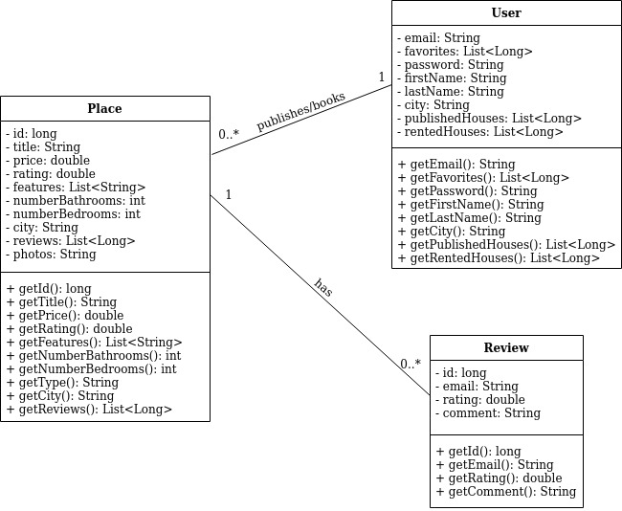

# Architecture notebook

## Key requirements and constraints

The system can be accessed through an Web Interface, contacting the url of the deployed service,

interacting directly to the service layer, or through an Android mobile device, making use of the API

provided by the product that will interact with the service layer. The mobile devices must use the

Android operating system.

To access and interact with the service, on the Web Interface or using the API, it is necessary to be

connected directly or through VPN to the Aveiro University network.

Concerning the API and the way that users can interact with it, documentation for the endpoints are

provided and available(see point 5).

Docker containers were used to make Continuous Deployment to the VM machine.

## Architectural view

The software architecture is presented in the next figure.

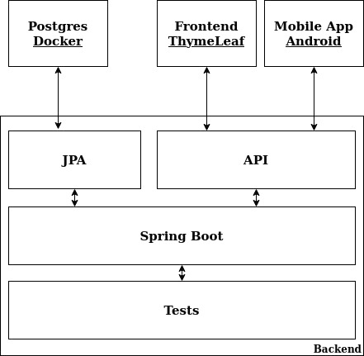

Given the above figure, for the backend it is being used Spring Boot, with the use of Controllers to respond to the API calls and the abstractions of JPA, capable of converting classes to database tables and vice versa. This database is a Postgres docker container, capable of storing all the data associated to the service like reviews, users and places. For the frontend, it was used HTML alongside with Thymeleaf and the external service, using the API endpoints is an android application.

## Deployment architecture

The Spring Boot Application and the PostgresSQL Database where both disposed in (different) Docker containers. Next, they were deployed to the VM available in Aveiro University, where the Android application contacts with the API and the Web application interacts with the HTML files with Thymeleaf.

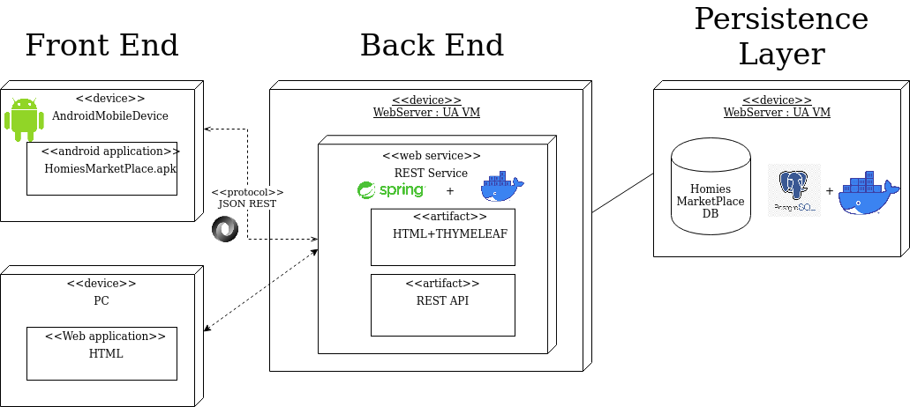

# API for developers

The API uses two main paths: the users and the places. For the users path, information about the users like his favorite houses or the houses that he booked. For the places endpoint, details about the place and reviews associated.

The documentation of the API can be found [here](https://app.swaggerhub.com/apis/HomiesMarketplace/homies-marketplace_api/1.0.0). An overview of the API documentation is presented next.

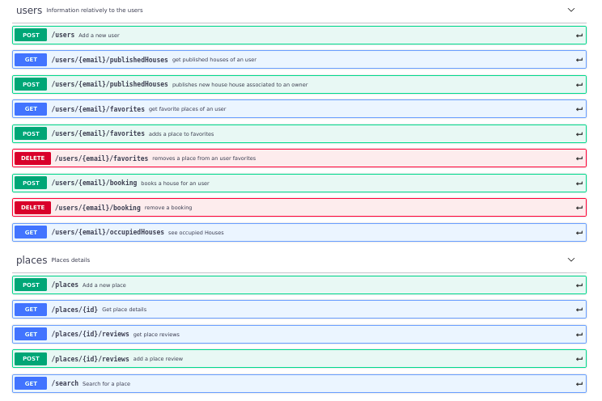

# References and resources

* [StackOverflow](https://stackoverflow.com/)
* [Baeldung – Spring Tutorial](https://www.baeldung.com/spring-tutorial)